Instructions on how to reverse code survey questions (Big 5 Survey used in this example)

<https://blog.jamovi.org/2018/10/23/transforming-variables.html>

* In the dataprep.Rmd file – make sure to run the code that saves the survey responses in a tidy format and save that as a new csv file
* Open the tidy csv file in jamovi
* There are 15 items in the Big 5 survey
* Items #3, 6, 10, and 14 need to be reversed coded

|  |  |  |
| --- | --- | --- |
|  | Regular | Reversed |
| Disagree strongly | 0 | 4 |
| Disagree a little | 1 | 3 |
| Neither | 2 | 2 |
| Agree a little | 3 | 1 |
| Agree strongly | 4 | 0 |

* Highlight the column of the first item you want to transform (big5_3)
* Under data, click Transform
* Relabel the variable so it makes sense to you (big5_3_R for reversed)
* Source variable should big big5_3 because that is the column of data we want to transform
* Using transform – click Create New Transform…
* Description: Reverse Code Big 5
* Description: reverse coding for big_5
* Variable suffix: …_rev
* + Add recode condition (you’ll need to add 4 if statements)
  + If $source == 0 use 4
  + If $source == 1 use 3
  + If$source == 3 use 1
  + If$source == 4 use 0
  + Else use 2
* 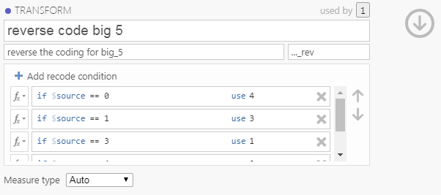Measure type: auto
* Now you can click the down arrow
* For the transformed variable big5_3_R, go to using transformation and select “reverse code big 5”

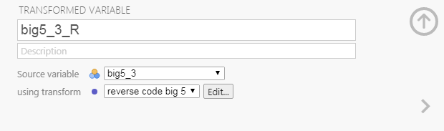

* Now repeat for items # 6, 10, and 14
* But from now on, all you have to do is create a transformed variable and select the “reverse code big 5” in the using transform drop down!
* So now when you do any analyses, you need to make sure to select the recoded variables and not the original ones